Name: ________________________________ Date: ________
Buddhism Mrs. Valdes

The Buddhist religion began in India around 500 B.C. Siddhartha Gautama, the founder of Buddhism, was the son of a wealthy and powerful king. As a prince, Siddhartha lived a life of comfort and luxury. But one day, Siddhartha left the palace and was shocked by all the human suffering he saw. He decided to leave his family, wealth, and comfort in search of truth. He joined a group of Hindu ascetics (people who practice self-denial for spiritual purposes). After nearly starving to death, Siddhartha left the ascetics and meditated under a tree. While meditating, Siddhartha became the Buddha or the “Enlightened One”.

Questions:
- Where and when did Buddhism originate? ______________________________________________________________________________________________________________________________________________________________________________________________________
- Who was Siddhartha Gautama? ______________________________________________________________________________________________________________________________________________________________________________________________________
- Why did Siddhartha leave the palace? ______________________________________________________________________________________________________________________________________________________________________________________________________
- Why did Siddhartha leave the ascetics? ______________________________________________________________________________________________________________________________________________________________________________________________________
- Who is the Buddha? ____________________________________________________________________________________________________________________________________ __________________________________________________________________

For the rest of his life, Buddha taught and preached. He walked from village to village, dressed in a yellow robe. Buddha preached the Four Noble Truths about the meaning of life.

The Four Noble Truths

- Life means suffering or nothing lasts forever. During a lifetime, a person experiences sickness, old age, and ultimately, death.
- The origin of suffering is selfish desire and attachment. Say you want something and you don't get it--you get sad or frustrated. But say you want something and you do get it. Eventually you'll get bored with it and you'll start wanting something else. And so you start all over again.
- Suffering can end. If a person stops wanting endlessly, he won’t suffer anymore. Buddhists believe that suffering is caused by endless wanting.
- Live by the Noble Eightfold Path. There are eight actions that help a person live a life that avoids extremes. Through right speech and action, a person can achieve the Middle Path.

Buddhists also believe in Karma and reincarnation. However, they believe that when desire ends, a person enters nirvana or complete peace and stops reincarnating. The basic beliefs of Buddhism are found in books called the Sutras.

Questions:

- Explain each of the Four Noble Truths.

- ____________________________________________________________________________________________________________________________________
- ____________________________________________________________________________________________________________________________________
- ____________________________________________________________________________________________________________________________________
- ____________________________________________________________________________________________________________________________________

- Define reincarnation and nirvana. ____________________________________________________________________________________________________________________________________
- What is the Middle Path? ____________________________________________________________________________________________________________________________________

- It is important to remember that Siddhartha was raised a Hindu but founded Buddhism. How does Buddhism differ from Hinduism? How is Buddhism similar to Hinduism? ________________________________________________________________________________________________________________________________________________________________________________________________________________________________________________________________________________________________________________________________________________________________________________________________________________________________________________________________________________________________________________________________________________
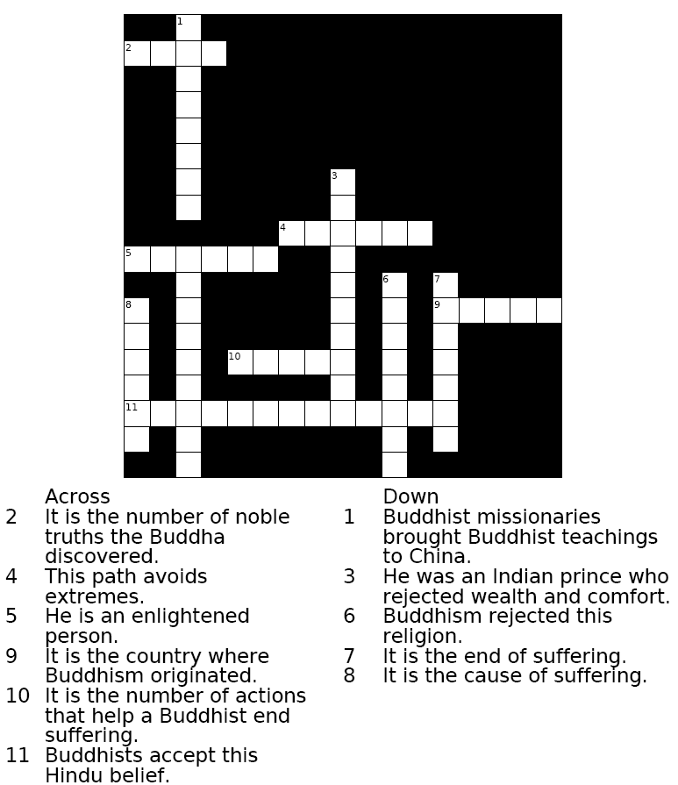

Word Bank:

Nirvana, Cultural Diffusion, Buddha, Middle, Reincarnation, Siddhartha, Desire, Eight, Four, India, Hinduism

Which belief system is most closely associated with the terms Eightfold Path, Four Noble Truths, and nirvana?

(1) Buddhism (3) Judaism
(2) Christianity (4) Shinto

The caste system in India was characterized by

(1) toleration for various religious beliefs
(2) equality between men and women
(3) a lack of social mobility
(4) the right of people to choose their occupations

Base your answer to question on the passage below and on your knowledge of social studies.

. . . He who, being of weak faculties [abilities], develops the wisdom of the first path with a dull insight is reborn seven times at most; after seven rebirths in states of bliss he will make an end of misery: he who develops it with medium faculties and insight is a roamer; after two or three rebirths he will make an end of misery: he who develops it with keen faculties and insight takes root but once, only one human birth will he pass through and make an end of misery. . . .
— Charles W. Eliot, ed., Sacred Writings, Vol II, P.F. Collier & Son, 1910

Which belief system is described in this passage?
(1) Buddhism (3) Islam
(2) Christianity (4) Confucianism

The Buddhist religion teaches that salvation is earned by
- following the Ten Commandments
- worshiping Allah as the one true god
- learning to give up selfish desire
- being baptized and confirmed

Which values are most closely associated with the fundamental principles of Buddhism?
- competition and financial success
- maintaining the caste system and providing education for all people
- practicing nonviolence and giving up worldly desires
- self-determination and democracy
Have compassion for all beings, rich and poor alike; each has their suffering. Some suffer too much, others too little.
Buddha

